**Step 01**: Creating and launching EC2 Instance

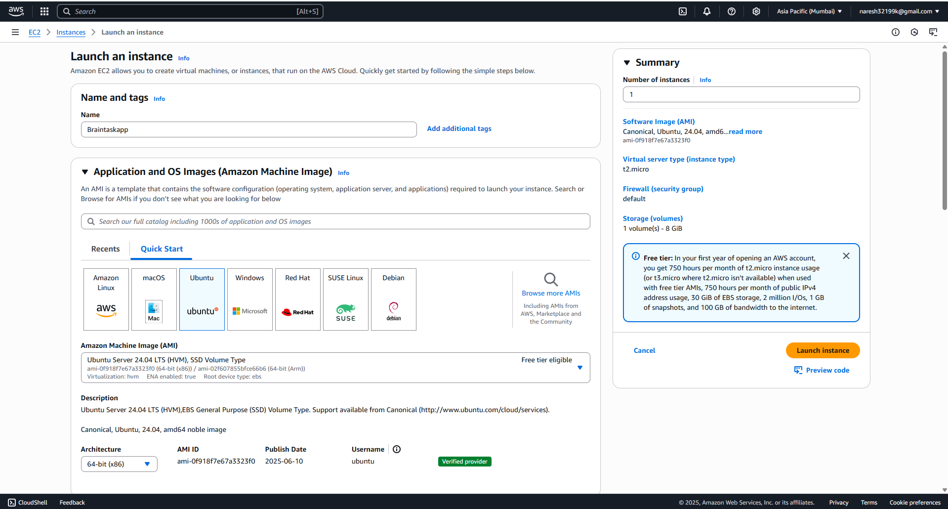

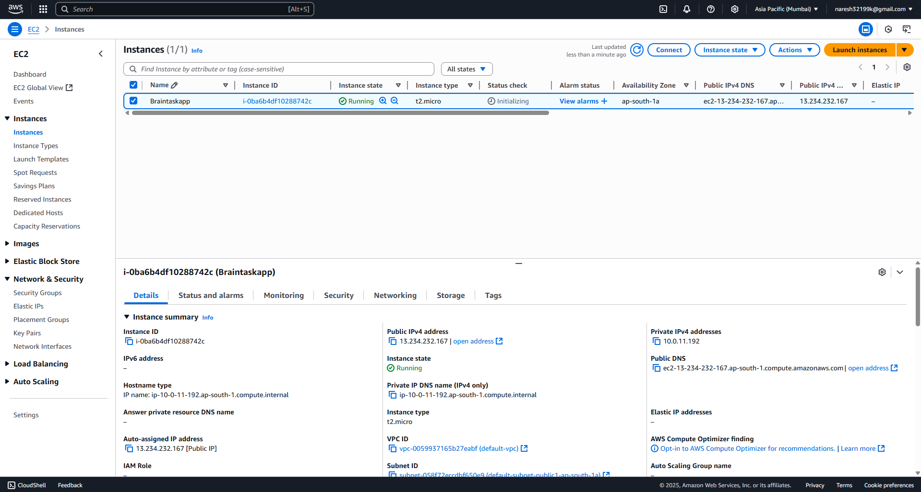

**Step 02:** Creating IAM role for EKS and attach it to the instance

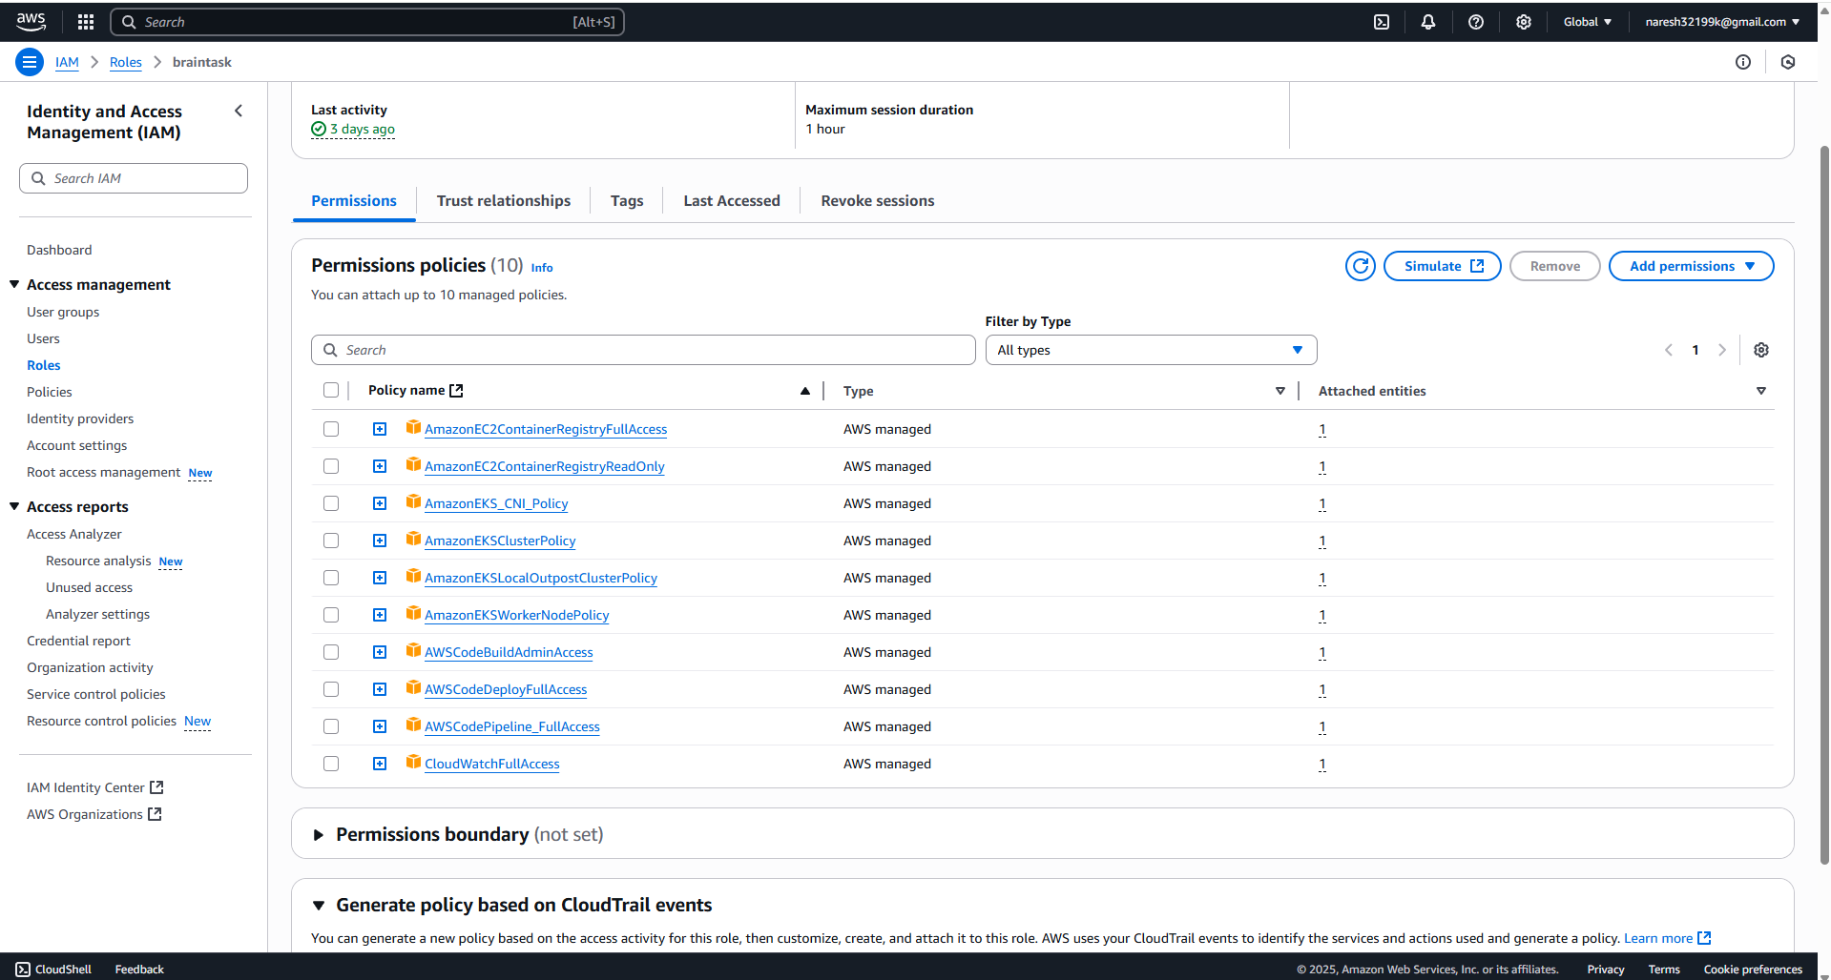

**Step 03**: Installing required tools /software

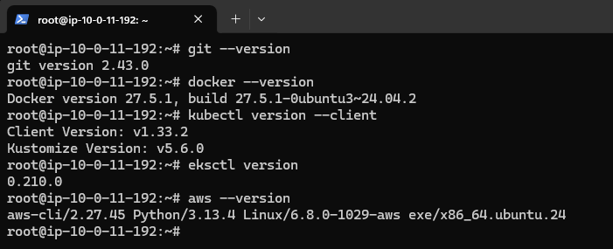

**Step 04**: Forking the project

**Step 05**: Cloning the repo

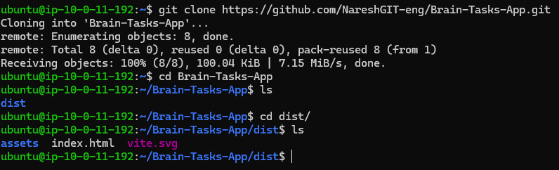

**Step 06**: Dockerize the application

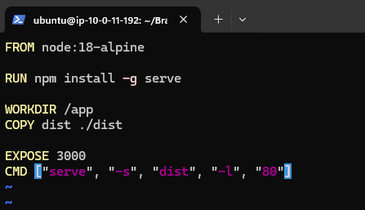

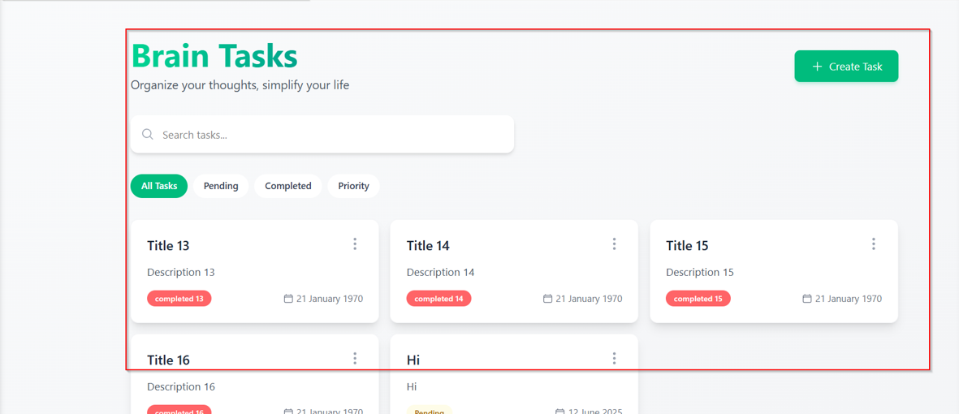

aws ecr get-login-password --region ap-south-1 | docker login --username AWS --password-stdin 440744235671.dkr.ecr. ap-south-1.amazonaws.com

docker tag brain:latest 440744235671.dkr.ecr. ap-south-1.amazonaws.com/brain-ecr:react_image

docker push 440744235671.dkr.ecr. ap-south-1.amazonaws.com/brain-ecr:react_image

**Step 07:** Creating EKS Cluster

eksctl create cluster --name brain-tasks-app-cluster --region ap-south-1 --nodegroup-name standard-workers --node-type t2.micro --nodes 3

**Step 08**: Deployment EKS

Deployment.yaml

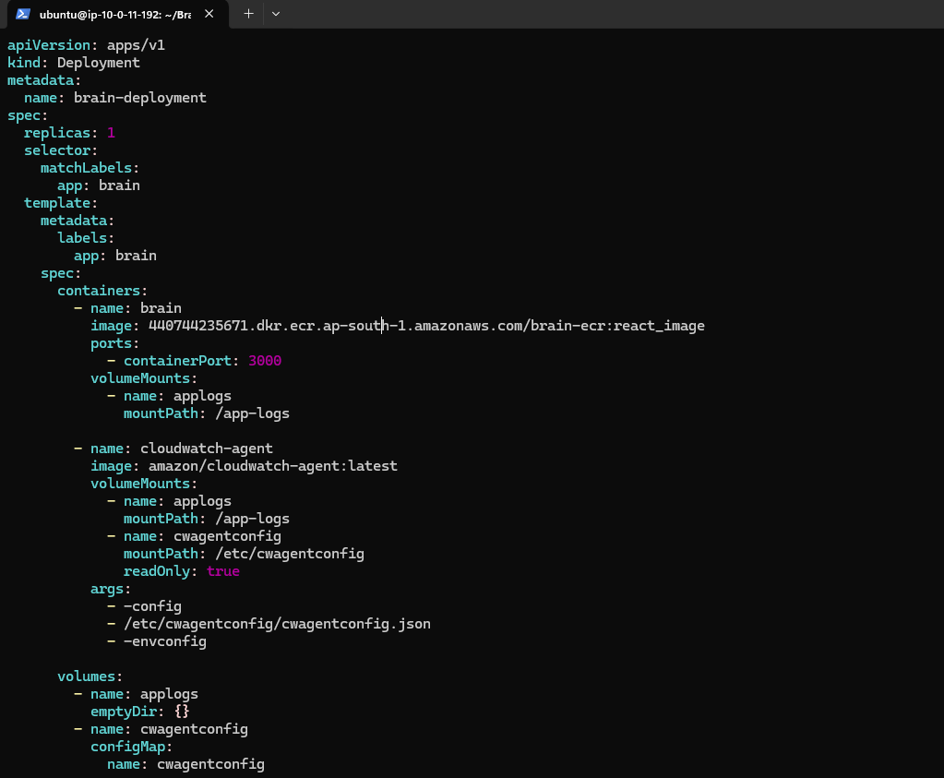

Service.yaml

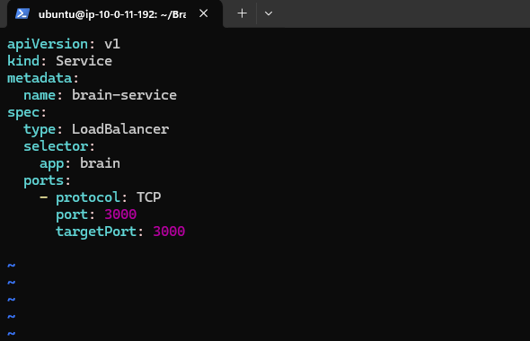

kubectl apply -f deployment.yaml

kubectl apply -f service.yaml

kubectl get svc



Application running in load balancer ARN:

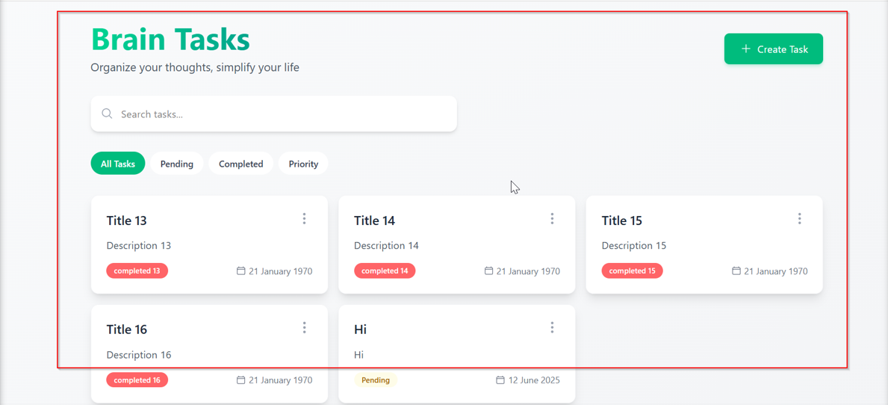

Step 09: CodeBuild

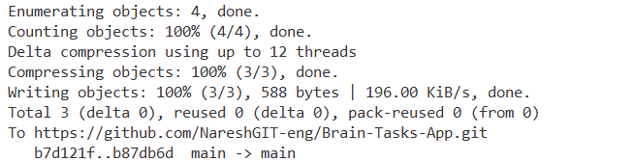

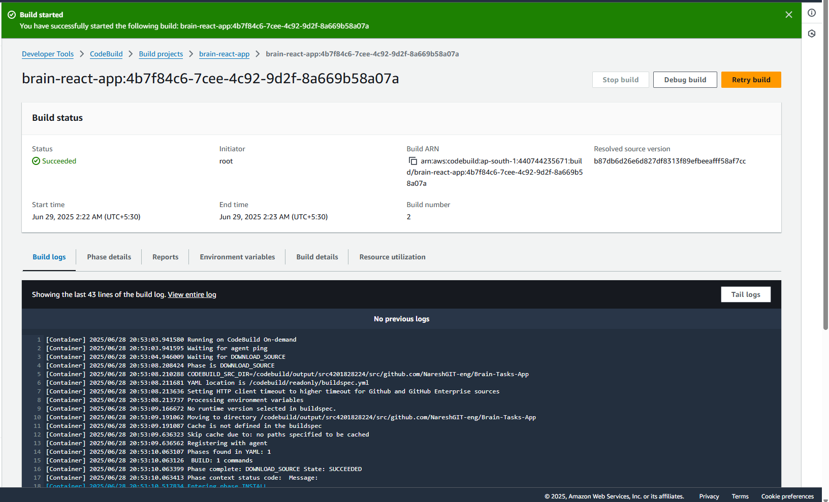

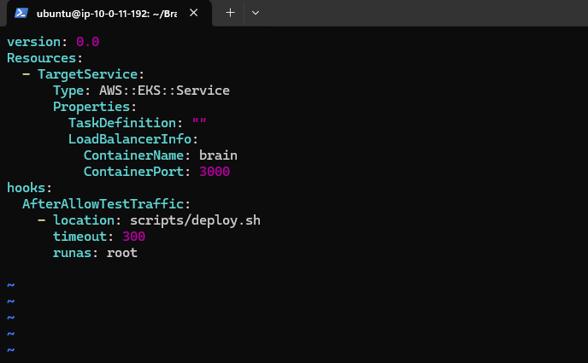

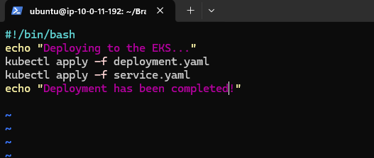

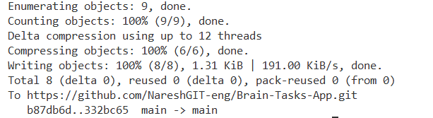

Cloud Watch

